Particle characterization - Particle size distribution
Submission dates
- Both request form (via email as a word document to alab.chemeng@uct.ac.za) and samples should be submitted on:
Monday | Friday
10:00 - 11:00
Minimum mass
- A minimum mass of 5 g of sample is required.

Information about the sample and dispersant
- For example, quartz:
 | Sample | Dispersant
Name of sample material | Quartz | Water
Refractive index (RI) | 1.55 | 1.33
Absorption index | 0.01 | -

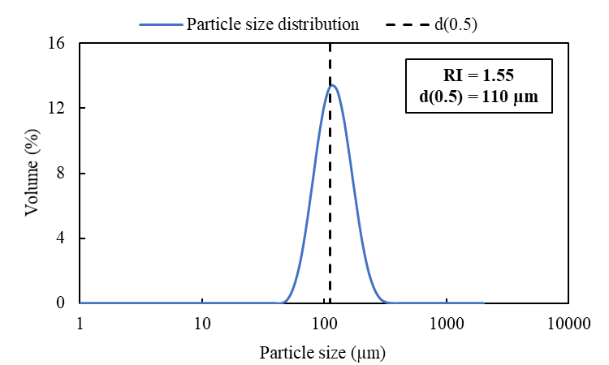 | 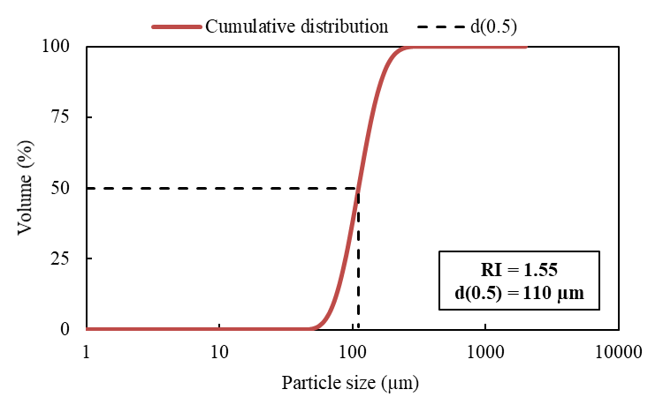
Estimated turnaround time for analysis
Turnaround option | Estimated time | Max number per week
Normal¹ | 1-2 weeks | N/A
Fast track² | 5-7 working days | 15 samples
ASAP³ | - working days | 6 samples
UGP⁴ | Highest priority | -
- Normal turnaround is often shorter than 1 – 2 weeks. It accounts for a queue and/or method development for new samples.
- Recommended for samples that we have analysed previously. A large batch of samples submitted might take longer than 5 – 7 working days.
- ASAP turnaround is only recommended for similar samples that we have analysed previously. We should have an established working method already.
- Reserved for 4th year UCT undergraduate students. Undergrad project samples given highest priority over other samples.

HOW TO GUIDE
SECTION A: TO BE COMPLETED BY CUSTOMER

Customer Details
Name:
Date sample/s + request form submitted:
Research group/Department: | Cost Centre/ Fund number:
E-mail: | Cell no:
Supervisor name:

Instrument/Type of Analysis
Malvern Panalytical Mastersizer 2000 - Particle size analyser (Discuss with analyst if not sure which unit to choose)
Large volume wet dispersion unit (Hydro2000G - 800 ml) | Tick to indicateþ
Small volume wet dispersion unit (Hydro2000SM - 100 ml)

Turnaround time - Tick to indicateþ  Normal Fast track ASAP | Supervisor approval for Fast track or ASAP: Yes  (See page 1 for more details)
Sample Information
Number of samples:
Type of sample - Tick to indicateþ  Mineral ore Catalyst Carbon Soil Cement  If other, please specify:  Refractive⁴ index of sample material:  Absorption⁴ index of sample material:  4) For more information please click here | Type of dispersant - Tick to indicateþ  Distilled water Deionised water Ethanol⁵  If other, please specify:  Refractive index of dispersant:  5) Ethanol can only be used in the small volume dispersion unit (Hydro2000SM).
Type of additive⁶ (optional) - Tick to indicateþ  Igepal CA-630 Sodium Hexametaphosphate Sodium Pyrophosphate  If other, please specify:  6) Discuss with analyst if uncertain. | Analysis⁷ (optional)  If you require different set of procedures, please specify numerically:  Measurement/s Run/s  7) We use a standard procedure of 3 measurements per sample run.
Have you declared all information about your sample? Yes or No

Start and Completion of Analysis
Analysis request number: RN2024-M
Request number assigned by:
Analyst/s assigned to task:
Date sample/s submitted: | Date analysis started:
Date request form submitted: | Date analysis completed:
Date request number sent: | Date report/results sent:
SECTION B: TO BE COMPLETED BY ANALYST/S
Notes on Sample Preparation and Analysis
Sample information:
The following table is applicable if all samples are of the same material.
No. of samples
Type of sample
Type of wet dispersion unit
Refractive index of sample material
Absorption index of sample material
Refractive index of dispersant
Number of measurements per analysis
Number of analyses per sample
Type of additive (optional)

SOP file name/s:

Observations/opinions:

