HOW TO GUIDE
Particle characterization - BET
Submission dates
- Both request form (via email as a word document to alab.chemeng@uct.ac.za) and samples should be submitted on:
Monday | Friday
10:00 - 11:00
Minimum mass
- A minimum sample mass of 0.5 g is required.
Expected BET SA ( m²/g) | Sample mass required
< 20 | 3-5 g
≥ 50 | 0.5 g
Degas temperature and hold time
Type of sample | Degas conditions
Zeolites | 350 °C, 3 hours
Other catalysts | 200 °C, 3 hours
Mineral ore | 60 °C, overnight
- The sample will be degassed to remove contaminants from the surface and pores, i.e., it will be heated under vacuum. For example:

Type of BET analysis
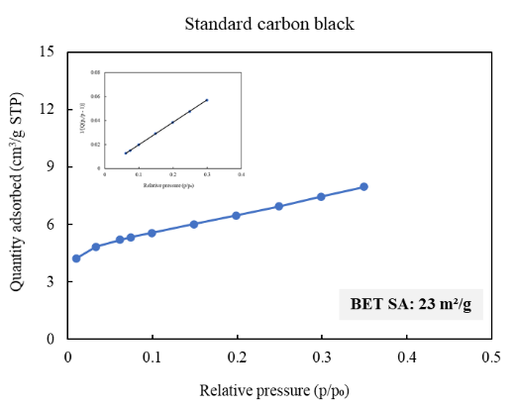  BET 10-point | 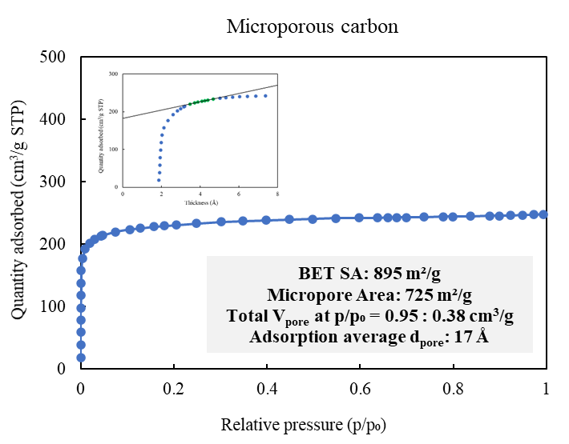  Adsorption and t-plot | BET and BJH  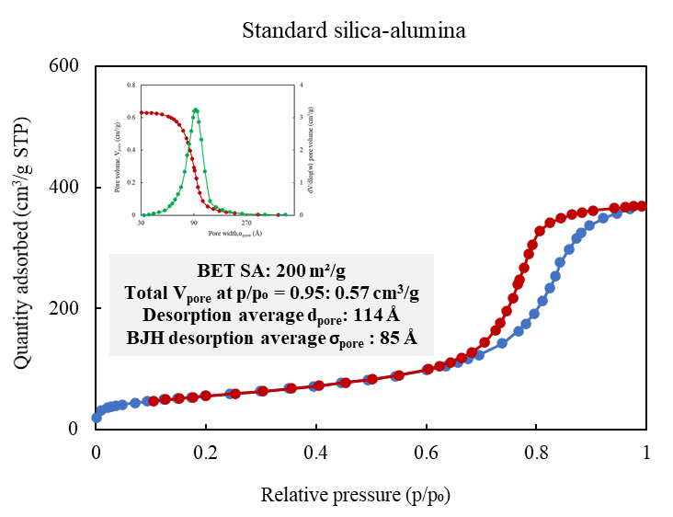
Estimated turnaround time for analysis
Turnaround option | Estimated time | Max number per week
Normal¹ | 2-3 weeks | N/A
Fast track² | 5-7 working days | 6 samples
ASAP³ | - working days | 3 samples
UGP⁴ | Highest priority | -
- Normal turnaround is often shorter than 2 – 3 weeks. It accounts for a queue and/or method development for new samples.
- Recommended for samples that we have analysed previously. A large batch of samples submitted might take longer than 5 – 7 working days.
- ASAP turnaround is only recommended for similar samples that we have analysed previously. We should have an established working method already.
- Reserved for 4th year UCT undergraduate students. Undergrad project samples given highest priority over other samples.
SECTION A: TO BE COMPLETED BY CUSTOMER
Customer Details
Name:
Date sample/s + request form submitted:
Research group/Department: | Cost Centre/Fund number:
E-mail: | Cell no:
Supervisor name:

Instrument/Type of Analysis
Tristar II 3020 - BET surface area, pore volume and pore size analysis Tick to indicateþ
BET 10-point analysis | Adsorption and t-plot analysis |  | BET and BJH analysis
Turnaround time: (Tick to indicateþ)  Normal Fast track ASAP UGP |  | Supervisor approval for Fast track or ASAP: Yes  (See page 1 for more details)
Sample Information
Number of samples:
Type of sample - Tick to indicateþ  Mineral ore Catalyst Carbon Soil Cement  If other, please specify: | Number of metals in sample:  Please specify:  Metal Concentration (wt%)
Type of pores in sample - Tick to indicateþ  Macroporous (> 50 nm) Mesoporous (2-50 nm) Microporous (< 2 nm) Non-porous | Expected BET SA - Tick to indicateþ  < 20 m²/g ≥ 50 m²/g
Degas temperature and hold time - Tick to indicateþ  60 °C, overnight 120 °C, overnight 200 °C, 3 hours 350 °C, 3 hours If other, specify  Is your sample stable at this degas temperature?  Yes or No | Does your sample contain anything else (e.g., organic species, acid pre-treatment, etc.)? Please specify:
Have you declared all information about your sample?
Yes or No

SECTION B: TO BE COMPLETED BY ANALYST/S
Start and Completion of Analysis
Analysis request number: RN2024-B
Request number assigned by:
Analyst/s assigned to task:
Date sample/s submitted: | Date analysis started:
Date request form submitted: | Date analysis completed:
Date request number sent: | Date report/results sent:
Notes on Sample Preparation and Analysis
Final degas conditions - Tick to indicateþ
60 °C, overnight | 120 °C, overnight | 200 °C, 3 hours | 350 °C, 3 hours | If other, specify

File Name/s:
Sample name | ANC file | SMP file | Analysis successful?

Observations/opinion:
Measured sample mass (g):
Sample no. | P/P₀ range | Thickness (Å) range for t-plot | BET SA (m²/g)

