HOW TO GUIDE
Particle characterization - BET
Submission dates
Monday | Friday
10:00 - 11:00 | 10:00 - 11:00
- Request forms should be sent via email as a word document to alab.chemeng@uct.ac.za, preferably before 10:00
- The request form must be submitted before the samples.
Minimum mass
- A minimum sample mass of 0.5 g is required.
Expected BET SA ( m²/g) | Sample mass required (g)
< 20 | 3-5
≥ 50 | 0.5
Degas temperature and hold time
- The sample will be degassed to remove contaminants from the surface and pores, i.e., it will be heated under vacuum. For example:
Type of sample | Degas conditions
Zeolites | 350 °C, 3 hours
Other catalysts | 200 °C, 3 hours
Mineral ore | 60 °C, overnight

Type of BET analysis
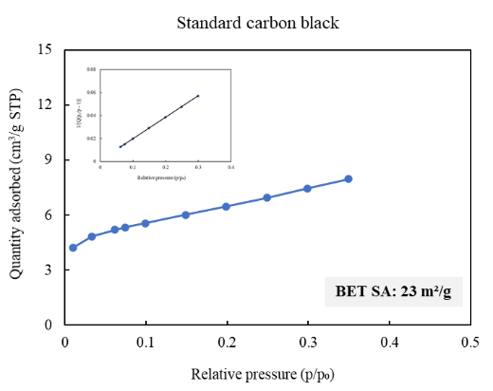  BET 10-point | 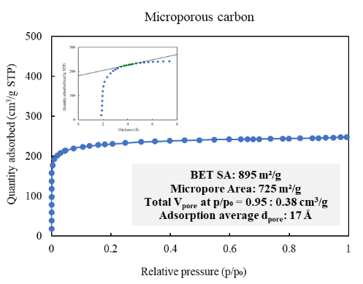  Adsorption and t-plot | BET and BJH  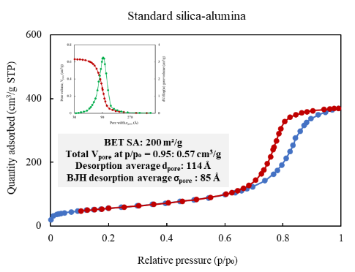
Estimated turnaround time for analysis
Turnaround option | Estimated time | Max number per submission
Normal¹ | 2-3 weeks | N/A
Fast track² | 5-7 working days | 6 samples
ASAP³ | - working days | 3 samples
- Normal turnaround is often shorter than 2 – 3 weeks. It accounts for a queue and/or method development for new samples. A large batch of samples (12 samples) submitted might take longer than 2 – 3 weeks.
- Recommended for samples that we have analysed previously. A large batch of samples (more than 6) submitted might take longer than 5 – 7 working days. For biochar samples the maximum number of samples are 3.
- ASAP turnaround is only recommended for similar samples that we have analysed previously. We should have an established working method already. We do not recommend biochar samples for this turnaround option.

SECTION A: TO BE COMPLETED BY CUSTOMER
Customer Details
Name and Surname: | Cell No:
Department: | Research group:
Supervisor name:
Cost Centre: | Fund number:
Date request form submitted: | Date sample/s submitted:
Instrument - Tristar II 3020 - BET surface area, pore volume and pore size analysis
Type of analysis, indicate with X
BET 10-point analysis | Adsorption and t-plot analysis | BET and BJH analysis

Sample Information
Type of pores in sample – Indicate with X | Expected BET SA – Indicate with X
  Macroporous  (> 50 nm) | Mesoporous  (2-50 nm) | Microporous  (< 2 nm) | Non-porous
  < 20 m²/g | ≥ 50 m²/g
Type of sample – Indicate with X If other, please specify: | Degas temperature and hold time
  Mineral ore | Catalyst | Carbon | Soil | Cement
  Temperature (°C) | Time (h)
Sample declaration – Indicate with X |  | YES | NO
Does your sample contain anything else (e.g., organic species, acid pre-treatment, etc.)?
Is your sample stable at the degas temperature you filled in?
Is there any safety information we need to know about the sample/s?
Have you declared all the information about your sample/s?
Specify anything else you would like to tell us about this request:

Turnaround time option
Number of samples | Indicate turnaround option with X |  |  | Supervisor approval for Fast Track
 | Normal | Fast Track | ASAP | Indicate turnaround option with X

SECTION B: TO BE COMPLETED BY ANALYST/S
Start and Completion of Analysis
Analysis request number: RN2026-B
Request number assigned by:
Analyst/s assigned to task:
Date sample/s submitted: | Date analysis started:
Date request form submitted: | Date analysis completed:
Date request number sent: | Date report/results sent:

Notes on Sample Preparation and Analysis
Final degas conditions - Tick to indicateþ
Time (h) | Temperature °C

File Name/s:
Sample name | ANC file | SMP file | Analysis successful?

Observations/opinion:

